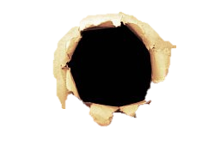

Questions?

Contact _____________________ for more information.

Feeding Supports Gastrointestinal Structure and Function

Adequate nutrition is associated with a decrease in complications, and hospital and ICU mortality

Optimal Nutrition Practices

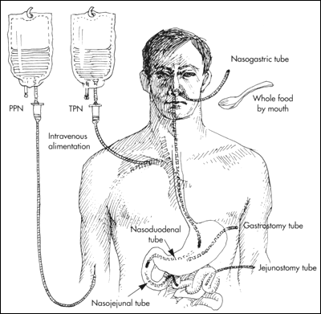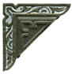

Reward

Wanted